NLP basic codes
Named Entity Recognition
Code:
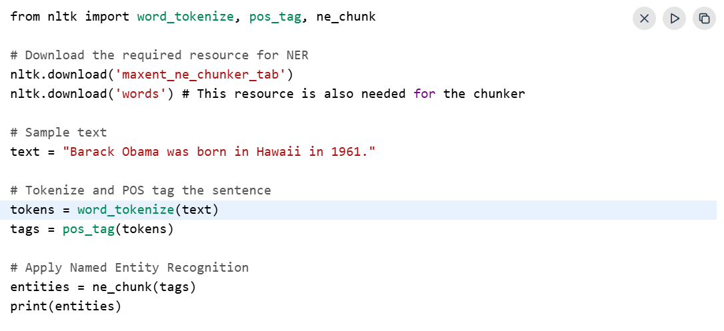
Output:
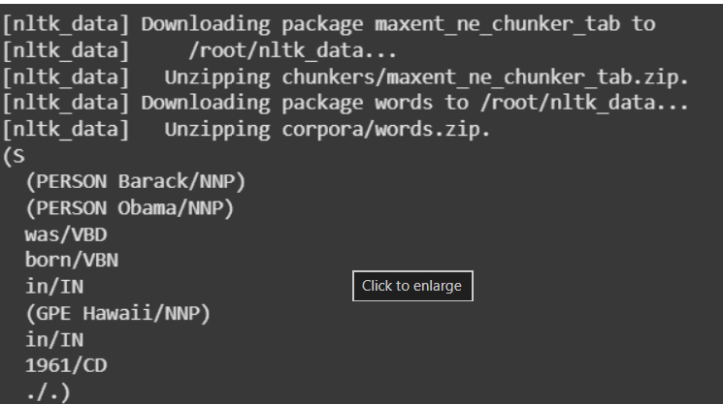
Tokenization Using Spacy
Features of SpaCy Tokenizer
- Performs fast and efficient tokenization on large text datasets
- Treats punctuation marks as separate tokens for accurate text processing
- Supports language-specific tokenization rules and grammar patterns
- Correctly handles spaces, newlines, URLs, hashtags, and email addresses
- Allows customization through user-defined tokenization rules
1. Blank Model Tokenization
In this method, SpaCy’s blank model spacy.blank("en") is used to perform basic tokenization without pre-trained NLP components such as POS tagging or named entity recognition.
- Initializes a minimal NLP pipeline
- Performs basic text tokenization
- Does not include pre-trained language processing features
Code:
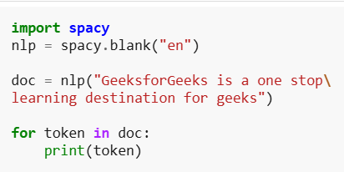
Output:
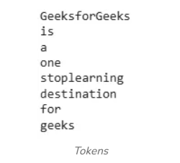
Displaying the Pipeline Components
In this step, the pre-trained en_core_web_sm model is loaded to access SpaCy’s NLP components. The pipeline components can then be displayed to view the available processing modules.
- Loads the pre-trained SpaCy model
- Displays available NLP pipeline components
- Includes components for tasks like tagging and parsing
Code:
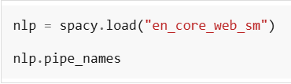
Output:
Tokenization with Part-of-Speech Tagging and Lemmatization
In this step, text is processed to perform tokenization, identify part-of-speech tags and extract the lemmatized form of each token.
- Splits text into tokens
- Assigns grammatical POS tags
- Extracts root or dictionary forms of words
Code:
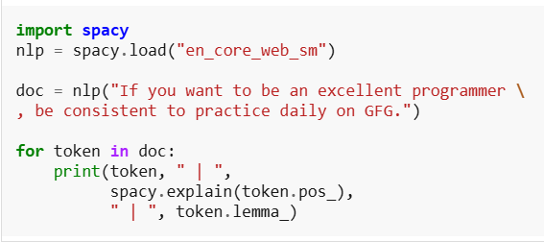
Output:
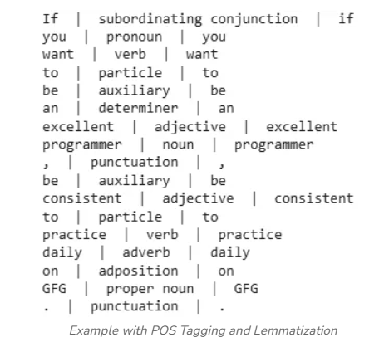
Advantages
- Provides fast and efficient tokenization for large text datasets
- Offers accurate tokenization using pre-trained NLP models
- Simple and user-friendly API for easy implementation
- Supports integration with tasks like lemmatization, parsing and NER
- Useful for building custom NLP pipelines and applications
Limitations
- Pre-trained models may require high memory usage
- Domain-specific text may need additional fine-tuning
- Performance can vary for languages with limited linguistic resources
- Large models may not suit memory constrained environments
TextBlob.sentiment() method
Sentiment analysis is used to identify the emotional tone of text as positive, negative or neutral. The TextBlob.sentiment() method provides two important measures for analyzing text sentiment.
- Polarity: Indicates whether the text is positive, negative, or neutral
- Subjectivity: Measures whether the text is opinion-based or factual
Code:
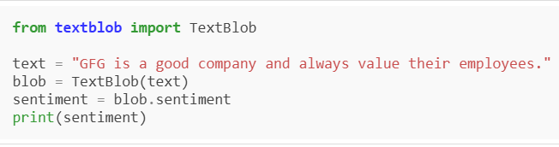
Output:
- Polarity: 0.7 means positive sentiment.
- Subjectivity: 0.6 means it’s more opinion-based.
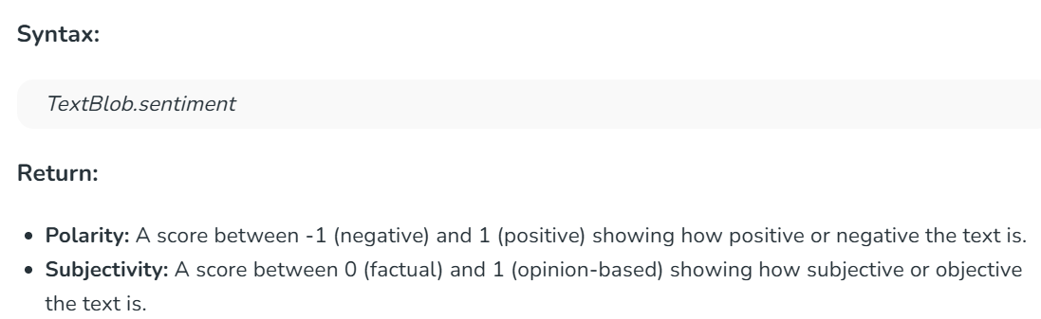
Negative Sentiment
Here, we analyze a sentence that expresses a strong negative sentiment. The polarity score reflects the negative tone while the subjectivity shows opinion-based statement.
Code:
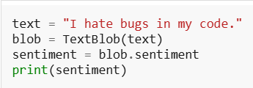
Output:
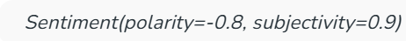
- Polarity: -0.8 shows a negative sentiment.
- Subjectivity: 0.9 shows the text is highly opinion-based.
- Neutral Sentiment
- In this example, we’ll analyze a neutral sentence that conveys factual information without expressing any strong opinion or emotion. It will show how TextBlob classifies a sentence with no sentiment bias.
Code:
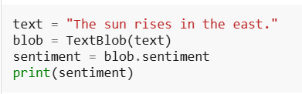
Output:
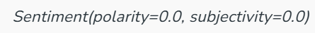
- Polarity: 0.0 means neutral.
- Subjectivity: 0.0 shows it's factual.
- Mixed Sentiment
- Here the sentence presents a neutral sentiment but is more opinion-based than factual. The polarity score remains neutral while the subjectivity score reflects an opinion or preference.
Code:
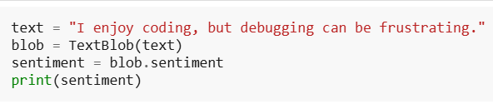
Output:
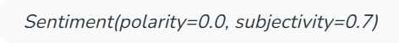
- Polarity = 0.0: This shows a neutral sentiment.
- Subjectivity = 0.7: The text is more opinion-based than factual as it's expressing a preference.
Applications
- Used in social media monitoring to analyze public opinion and trends
- Helps businesses evaluate customer feedback and satisfaction levels
- Supports content moderation by detecting negative or inappropriate comments
- Assists in understanding user emotions and reactions in real time
Limitations
- Struggles to understand sarcasm and irony accurately
- Uses a basic lexicon, limiting understanding of complex text
- May misinterpret sentences containing mixed sentiments
- Less effective for nuanced or context-dependent language
Introduction to Hugging Face Transformers
Hugging Face is an open-source platform that helps in building, training and deploying AI models for tasks like natural language processing, computer vision and audio. It offers libraries, ready-to-use models and tools that make it easier for developers, students and researchers to create and work with AI systems efficiently.
Core Components
Hugging Face Transformers provides core components that simplify the machine learning workflow, from data processing to model deployment, making development faster and more efficient.
1. Tokenizers
Tokenizers convert raw input (text, images or audio) into a format that models can process.
- Break input into tokens (subwords, words or IDs)
- Handle padding, truncation and attention masks
- Optimized for speed using Rust based implementations
- Ensure compatibility with specific model architectures
2. Pipeline
Pipeline provides a high level interface to run models quickly without managing internal complexities.
- Combines preprocessing, model inference and postprocessing
- Supports tasks like text classification, translation and image recognition
- Ideal for rapid prototyping and testing
- Reduces boilerplate code significantly
3. Datasets
Datasets library manages large scale data efficiently for training and evaluation.
- Access datasets across NLP, computer vision and audio domains
- Supports fast loading, filtering and transformation
- Enables streaming and memory efficient processing
- Integrates seamlessly with training pipelines
4. Transformers Library
Transformers is the core library that provides model architectures and training capabilities.
- Supports PyTorch, TensorFlow and JAX
- Includes state of the art architectures like BERT, GPT, ViT and more
- Enables fine tuning, training and inference
- Provides modular and reusable APIs for flexibility
5. Model Hub
Model Hub is a centralized repository for sharing and discovering models.
- Hosts thousands of pre trained and fine tuned models
- Allows versioning, collaboration and deployment
- Supports multiple modalities (text, vision, audio, multimodal)
- Encourages open source contributions and experimentation
6. Spaces
Spaces is a user-friendly platform that allows anyone to showcase machine learning models through interactive demos.
- Packages models in a simple interface, making them easy to use and share.
- Provides the computing resources needed to host demos directly on the platform.
- Makes AI models accessible to all users, regardless of technical background.
7. Pre-trained Models
Pre-trained models are ready to use models trained on large datasets to accelerate development.
- Cover NLP, computer vision, audio and multimodal tasks
- Reduce training time and computational cost
- Can be fine tuned for specific use cases
- Examples include BERT, GPT, T5 and Vision Transformers (ViT)
To use hugginf face we need to use hugging face website, then have to registor ourself and use.
Applications
- Enable automated text classification for tasks such as sentiment analysis and spam detection.
- NER models extract important entities such as names, dates and locations from text.
- Transformers like T5 helps in question answering systems that extract precise answers from text or documents.
- Models like GPT-2, GPT-Neo, GPT-J and T5 can generate creative text and summarize long documents.
Challenges
- Large models like GPT and BERT require significant computational power which may be hard for users with limited resources.
- Scaling models for enterprise level use can be challenging and may require additional resources.
- Models shared by the community can vary in quality requiring users to assess them carefully.
NLP Gensim Tutorial
Gensim is an open-source Python library used for efficient text processing, topic modeling and vector-space modeling in NLP. It is designed for speed and memory efficiency, making it suitable for handling large text datasets.
- Supports Word2Vec, Doc2Vec and LDA
- Handles large datasets through streaming and incremental training
- Widely used for semantic analysis, topic discovery and text similarity tasks
1. Common Terminologies
Let us understand what some of the below mentioned terms mean before moving forward.
- Corpus: A corpus is a large and structured collection of text documents used for training or analyzing language models.
- Vector: A vector is the numerical representation of text data that helps machines process and understand language.
- Model: A model is a machine learning or statistical algorithm that learns patterns from data for prediction or analysis.
- Topic Modelling: Topic modeling is an unsupervised learning technique used to discover hidden topics within a collection of documents.
- Topic: A topic is a group of related words that frequently appear together and represent a common subject or idea.
3. Create a Corpus from a given Dataset
You need to follow these steps to create your corpus:
- Load your Dataset
- Preprocess the Dataset
- Create a Dictionary
- Create Bag of Words Corpus
3.1 Load your Dataset
You can have a .txt file as your dataset or you can also load datasets using the Gensim Downloader API. Here, we have loaded a text file.
Code:
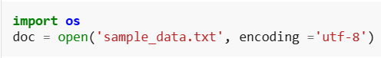
Gensim Downloader API: This is a module available in the Gensim library which is an API for downloading, getting information and loading datasets/models.
api.info() helps you find out what models and datasets are available, while api.load() lets you use them in your Python program.
Code:
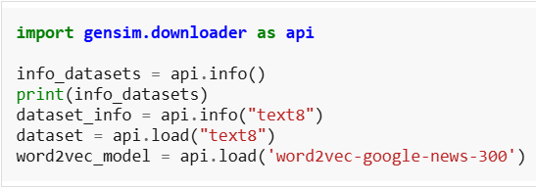
3.2 Preprocess the Dataset
Text preprocessing is used to clean and prepare text data for NLP tasks. The simple_preprocess() function tokenizes and normalizes the text by converting it into lowercase tokens and removing unwanted characters.
- Cleans and normalizes text data
- Converts text into tokens
- Removes punctuation and special characters
- Returns processed text as a list of tokens
Code:
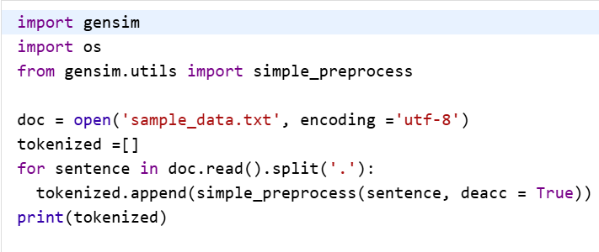
In Python, encoding='utf-8' specifies the character encoding used to read or write a file. UTF-8 supports English letters, numbers, symbols, and many languages such as Hindi, Marathi, and others.
In Python, especially in Gensim, deacc=True means remove accent marks from words.
Output:
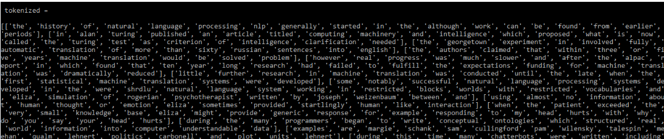
3.3 Create a Dictionary
Now we have our preprocessed data which can be converted into a dictionary by using the corpora.Dictionary( ) function. This dictionary is a map for unique tokens.
In Gensim, corpora.Dictionary() is used to create a dictionary that assigns a unique ID to each distinct word in a collection of text documents.
It is commonly used in Natural Language Processing (NLP) to convert text into a numerical representation.
Code:
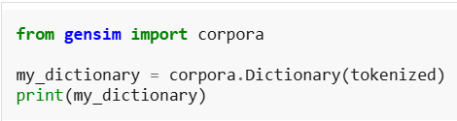
Output:
Saving Dictionary on Disk or as Text File: You can save/load your dictionary on the disk as well as a text file as mentioned below.
Code:
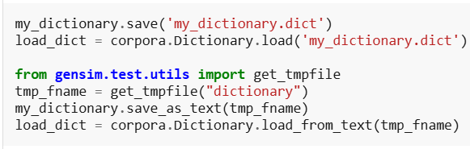
3.4 Create Bag of Words Corpus
After creating the dictionary, the doc2bow() function is used to create a Bag of Words corpus. It converts words into IDs and counts how many times each word appears in a document.
Code:
Output:
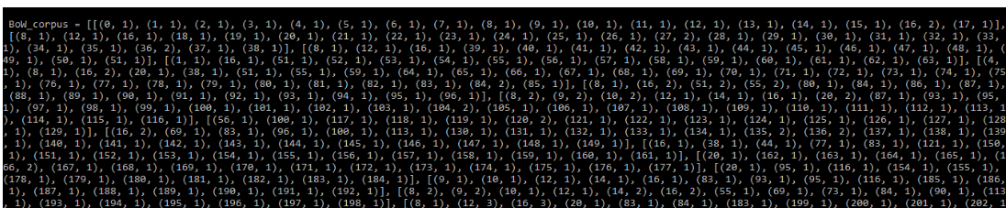
Saving Corpus on Disk: Now, save/load the corpus
Code:
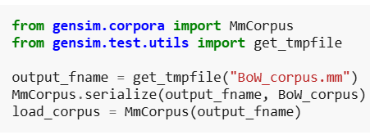
4. Create a TFIDF matrix in Gensim
TF-IDF stands for Term Frequency – Inverse Document Frequency. It is used to identify important words in documents by reducing the importance of commonly occurring words across the corpus.
- Highlights important words in documents
- Reduces the weight of frequently occurring common words
- Helps identify meaningful keywords
- Commonly used in text analysis and information retrieval
4.1 Building a BOW corpus
You can build a TFIDF model using Gensim and the corpus you developed previously as:
Code:
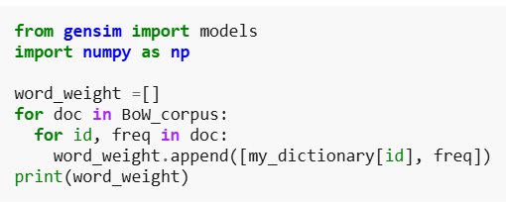
Output:
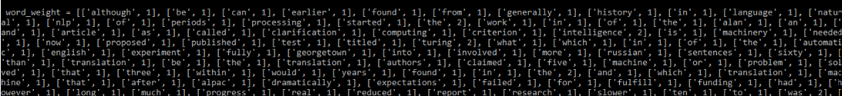
4.2 Applying TF-IDF Model
Code:
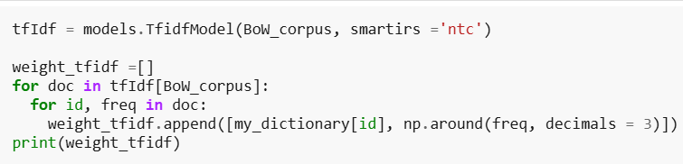
Output:
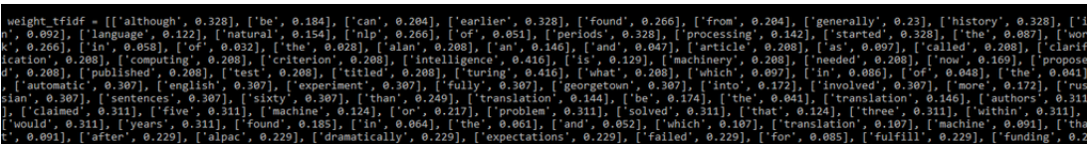
5. Creating Bigrams and Trigrams with Gensim
5.1 Loading Dataset using Gensim Downloader API
We will be building bigrams and trigrams using the text8 dataset here which can be downloaded using the Gensim downloader API.
Code:
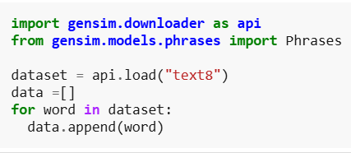
5.2 Building Bigram using Phraser Model
Here, we are building a bigram using Phraser Model.
Code:
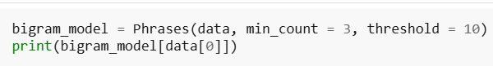
Output:
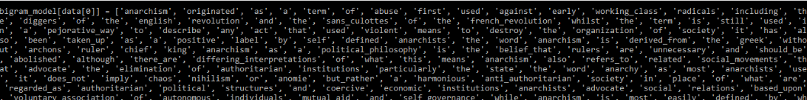
5.3 Building Trigram using Phraser Model
To create a Trigram we simply pass the above obtained bigram model to the same function.
Code:
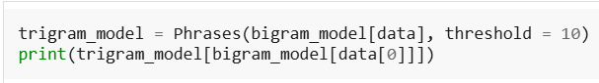
Output:
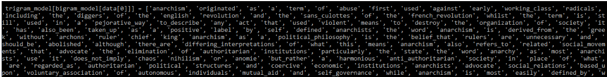
6. Create Word2Vec model using Gensim
Machine learning models cannot process text directly, so words must be converted into numerical representations called word embeddings. Unlike CountVectorizer and TF-IDF, Word2Vec preserves relationships between words by mapping them into a vector space.
- Converts words into numerical vectors
- Preserves semantic relationships between words
- Supports mathematical operations on word vectors
- Pre-trained models like Word2Vec, GloVe and FastText can be loaded using Gensim
- Custom Word2Vec models can also be trained on datasets

6.1 Train the model

Code:

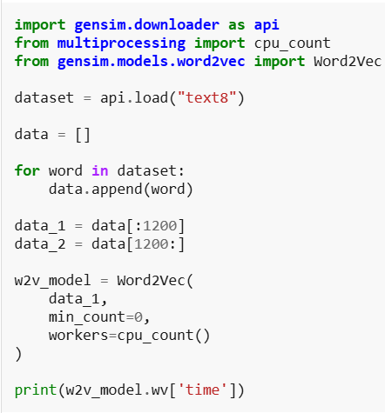
Output:
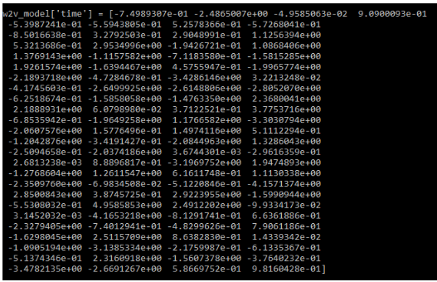
You can also use the most_similar( ) function to find similar words to a given word.
Code:
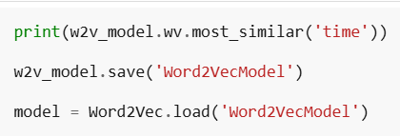
Output:
6.2 Update the model
Code:
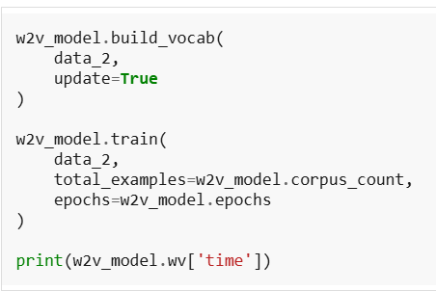
Output:
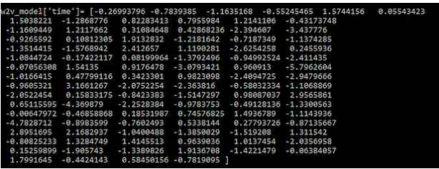
7. Create Doc2Vec model using Gensim
Doc2Vec extends Word2Vec by generating vector representations for entire documents instead of individual words. It helps identify relationships and similarities between documents based on their content.
7.1 Train the model
Load the dataset, Define a function to list the tagged documents, and train the dataset.
Code:
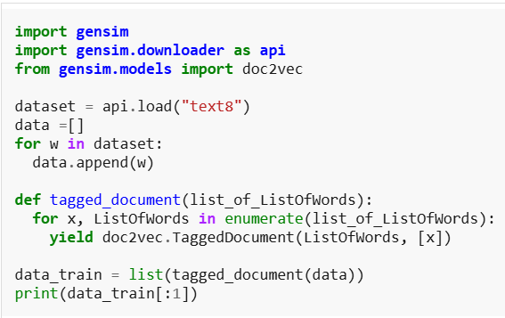
Output:
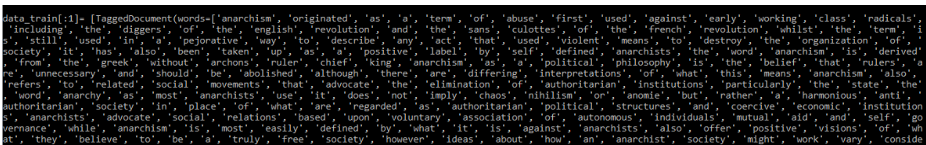
7.2 Update the model Code
Initialize the model, build the vocabulary, Train the Doc2Vec model and Analyze the output.
Code:
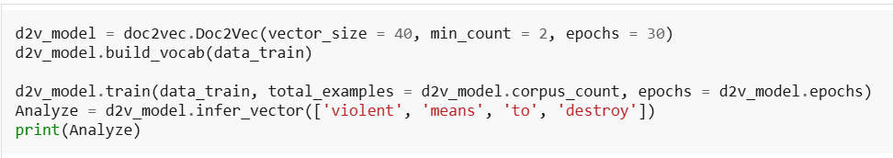
Output:
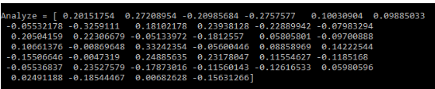
8. Topic Modelling
Topic Modelling using Gensim
8.1 Illustration of NLP Topic-based Categorization
Topic modeling groups related words into meaningful topics based on their occurrence patterns in documents.
Some of the Topic Modelling Techniques are:
- Latent Dirichlet Allocation (LDA)
- Latent Semantic Indexing (LSI)
8.2 Topic Modelling using LDA
Latent Dirichlet Allocation (LDA) is a topic modeling technique that treats each document as a mixture of multiple topics. The quality of generated topics depends on text preprocessing, selecting the optimal number of topics and tuning model parameters.
- Identifies hidden topics in documents
- Represents documents as combinations of topics
- Topic quality depends on preprocessing and parameter tuning
8.2.1 Prepare the Data
Data preparation includes removing stopwords and performing lemmatization before training the LDA model.
- Removes unnecessary stopwords
- Applies lemmatization for word normalization
- Uses Gensim and NLTK for preprocessing tasks.
Code:
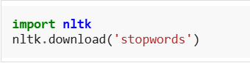
Here, we have pre-processed the data by removing stopwords and lemmatization.
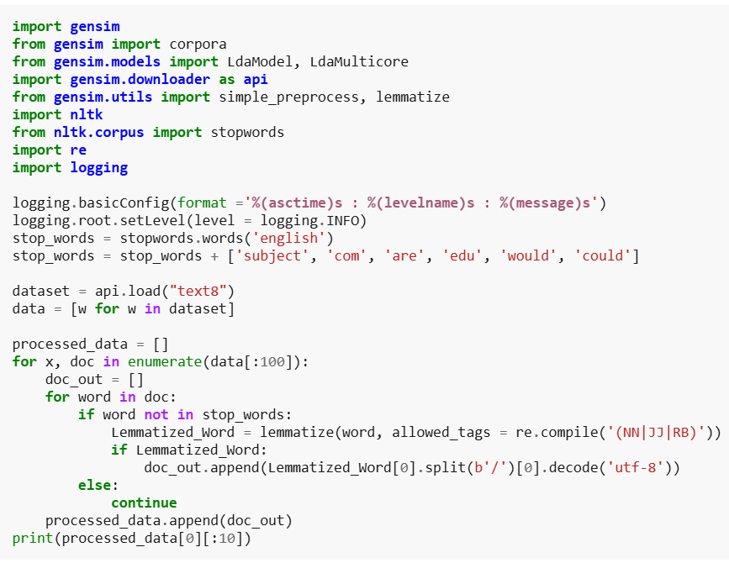
Output:
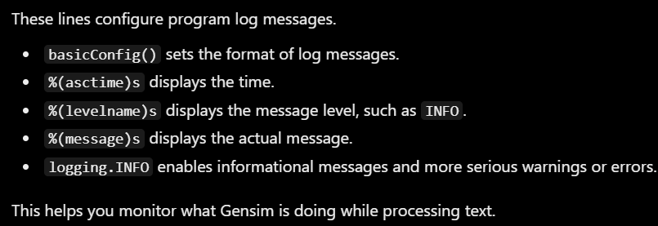
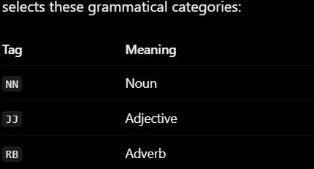
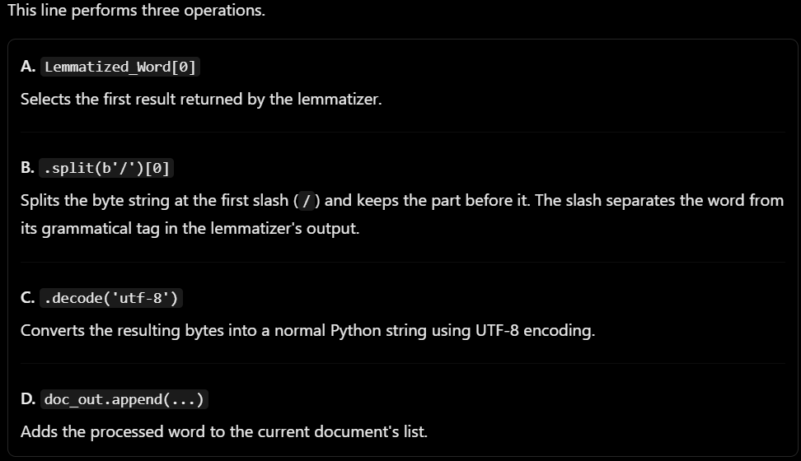
8.2.2 Create Dictionary and Corpus
The processed data will now be used to create the dictionary and corpus.
Code:
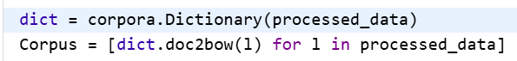
8.2.3 Train LDA model
LDA stands for Latent Dirichlet Allocation. It is a machine learning algorithm used in Natural Language Processing (NLP) to discover hidden topics in a collection of documents. LDA is useful for:
- Topic discovery: Finds hidden themes in documents.
- Document classification support: Helps identify which topics a document discusses.
- News analysis: Groups articles by subjects such as sports, politics, and technology.
- Customer feedback analysis: Finds common themes in reviews.
- Research analysis: Identifies recurring topics in research papers.
- Large text collections: Helps summarize the main themes across many documents.
We will be training the LDA model with 5 topics using the dictionary and corpus created previously. Here the LdaModel( ) function is used but you can also use the LdaMulticore( ) function as it allows parallel processing.
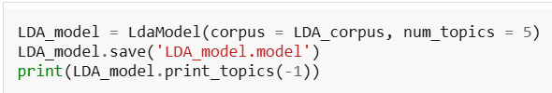
Output:
8.2.4 Interpret the Output
The LDA model majorly gives us information regarding 3 things:
- Topics in the document
- What topic each word belongs to
- Phi value: Probability of a word to lie in a particular topic. For a given word, sum of the phi values give the number of times that word occurred in the document.
Code:
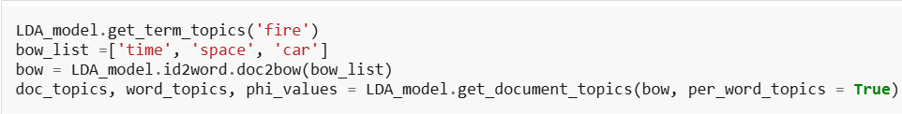
8.3 Topic Modelling using LSI
To create the model with LSI just follow the steps same as with LDA. The only difference will be while training the model. Use the LsiModel( ) function instead of the LdaMulticore( ) or LdaModel( ). We trained the model using LSI and then printed the topics.
Code:
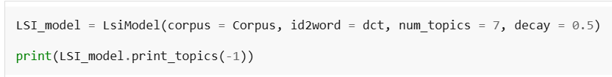
9. Compute Similarity Matrices
Similarity matrices are used in NLP to measure how closely related two text documents or vectors are. Cosine similarity compares vectors based on the angle between them, while soft cosine similarity also considers relationships between similar words using word embeddings.
- Soft cosine similarity considers semantic similarity between words
- Values closer to 1 indicate higher similarity
- Word embeddings like Word2Vec are used for soft cosine similarity
- Commonly used in text analysis and information retrieval
Code:
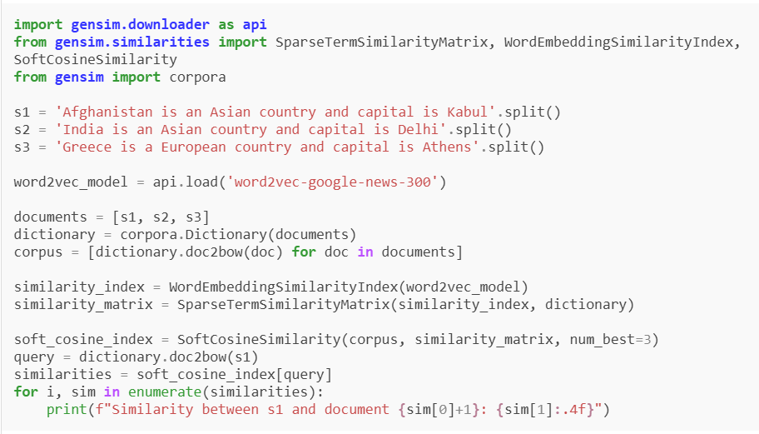
Output:
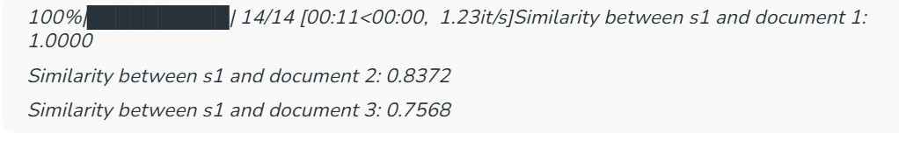
10. Text Summarization using Gensim
Gensim provides the summarize() function for automatic text summarization using the TextRank algorithm. It extracts the most important sentences from a document to generate a shorter summary.
- Uses the TextRank summarization technique
- Automatically identifies important sentences
- No need for manual tokenization or sentence splitting
- Useful for summarizing large text documents
Code:
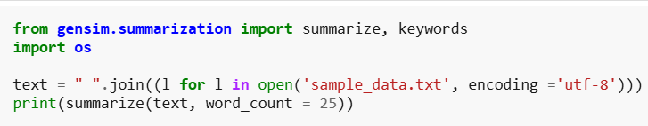
Output:
11. Extracting Important Keywords from Text
You can get the Important keywords from the paragraph.
Code:
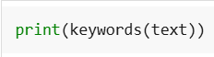
Output:
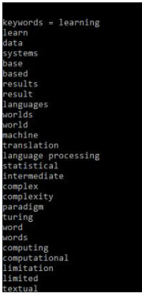
Gensim library comes most handy while working on language processing.
Tokenization:
Types of tokenization:
- Word Tokenization: This is the most common method where text is divided into individual words. It works well for languages with clear word boundaries, like English.
- Character Tokenization: In this method, text is split into individual characters. This is particularly useful for languages without clear word boundaries or for tasks that require a detailed analysis, such as spelling correction.
- Sub-word Tokenization: Sub-word tokenization strikes a balance between word and character tokenization by breaking down text into units that are larger than a single character but smaller than a full word.
- Sentence Tokenization: Sentence tokenization is also a common technique used to make a division of paragraphs or large set of sentences into separated sentences as tokens.
- N-gram Tokenization: N-gram tokenization splits words into fixed-sized chunks (size = n) of data.
Code and output:
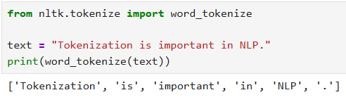
Using spacy, code and output:
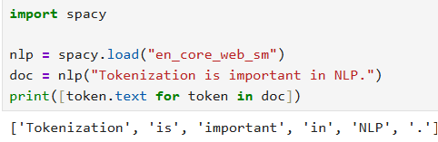
Challenges
Despite its importance, tokenization faces several challenges:
- Ambiguity: Human language is inherently ambiguous. A sentence like "I saw her duck" can have multiple interpretations depending on the tokenization and context.
- Languages Without Clear Boundaries: Languages like Chinese and Japanese do not have clear word boundaries, making tokenization more complex.
- Special Characters: Handling special characters such as punctuation, email addresses, and URLs can be tricky. For instance, "john.doe@email.com" could be tokenized in multiple ways and interpretations, complicating text analysis.
- Out-of-Vocabulary Words: Words not present in the training data can be difficult to tokenize correctly, especially new or rare terms.
- Compound Words: Words formed by combining multiple words may be split incorrectly, which can affect meaning.
- Multi-word Expressions: Phrases like "New York" or "ice cream" may lose meaning if tokenized as separate words.
- Domain-Specific Terms: Technical or specialized vocabulary may not be handled properly by general-purpose tokenizers.
Removing stop words with NLTK in Python
Stop words are frequently occurring words such as “is”, “the”, “and”, and “of” that may contribute little to certain text analysis tasks. Removing them is a common NLP preprocessing technique used to reduce unnecessary tokens and focus on relevant words.
NLTK (Natural Language Toolkit) provides predefined stop-word lists for multiple languages. We can use its stopwords corpus along with word tokenization to identify and remove these words from text. However, stop-word removal is task-dependent and may not improve every NLP application.
- Stop words are high-frequency, low-meaning words in text data
- They are often removed during preprocessing in NLP pipelines
- Removal helps improve efficiency and model performance in many tasks
- Different libraries provide built-in stopword lists (NLTK, SpaCy, etc.)
Code and output:
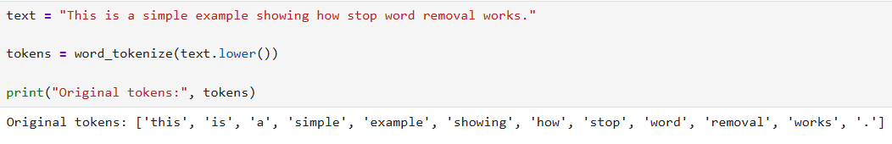
Explanation:
- Text variable stores the sample sentence.
- lower() converts the sentence to lowercase so that words can be compared consistently with the stop-word list.
- word_tokeinze() separates the sentence into words and punctuation marks.
- 3. Loading Stop words and Filter Tokens
- Load the English stop-word list and remove matching tokens from the sentence.
Code and output:
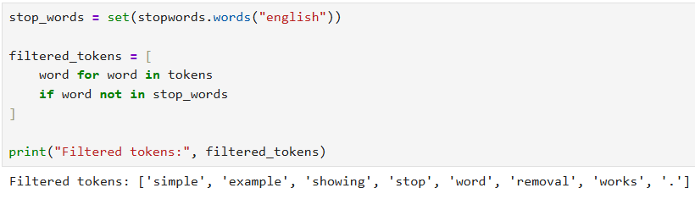
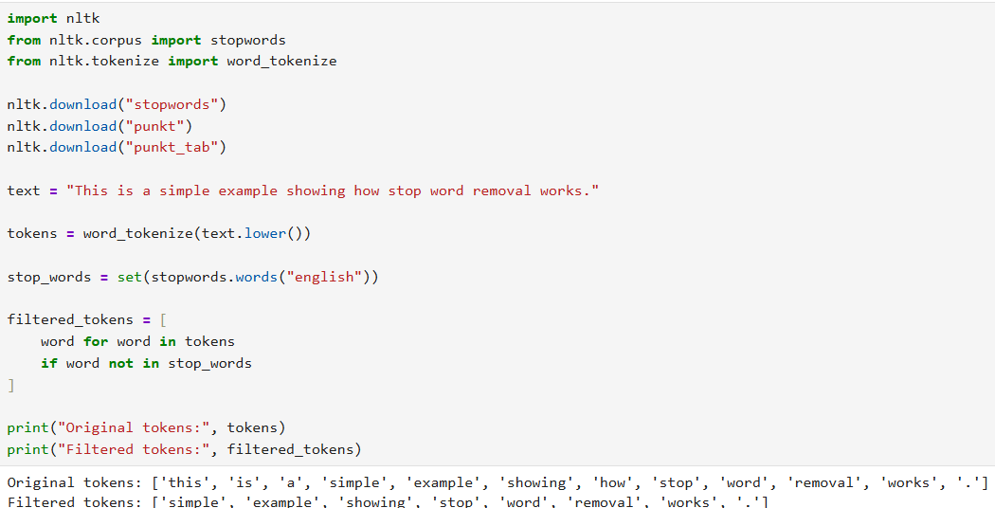
Explanation:
- stopwords.words("english") returns the predefined English stop-word lists.
- set() converts the list into a set for efficient membership checks.
- List comprehension retains only tokens that are not present in stop-words.
- Period remains because punctuation is not automatically removed by this filtering operations.
Punctuation removal:
Code and output:
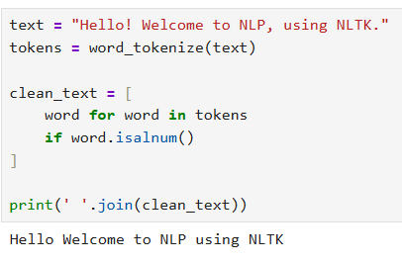
Stemming:
Types of stemming:
1. Porter's Stemmer
Porter's Stemmeris one of the most widely used stemming algorithms in NLP. It removes common suffixes from English words using a set of predefined rules to produce root forms.
- Simple, fast and efficient stemming algorithm
- Removes common suffixes from words
- Mainly designed for the English language
- Widely used in text preprocessing tasks
- Stemmed words may not always be meaningful dictionary words
Advantages
- Very fast and efficient.
- Commonly used for tasks like information retrieval and text mining.
Limitations
- Outputs may not always be real words.
- Limited to English words.
Code and output:
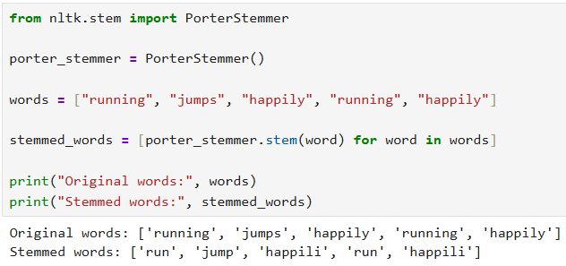
2. Snowball Stemmer
Snowball Stemmer is an improved version of Porter’s Stemmer, also known as Porter2. It is faster, more aggressive, and supports multiple languages for stemming tasks.
- Improved and faster version of Porter’s Stemmer
- Removes suffixes more effectively
- Supports multiple languages
- Commonly used for multilingual text processing
- Produces more consistent stemming results
Advantages
- More efficient than Porter Stemmer.
- Supports multiple languages.
Limitations
- More aggressive which might lead to over-stemming.
Code and output:
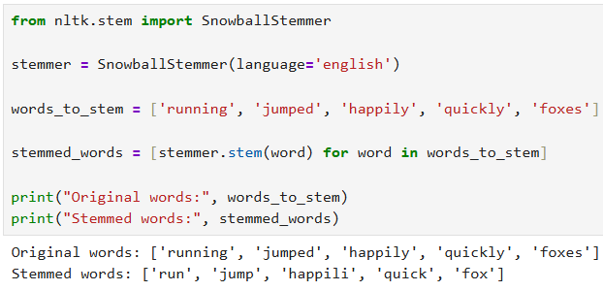
3. Lancaster Stemmer
Lancaster Stemmer is a fast and aggressive stemming algorithm that reduces words to very short root forms using iterative rule-based processing.
- Faster and more aggressive than many other stemmers
- Applies rules repeatedly to reduce words
- Can produce very short or distorted stems
- Useful for applications requiring fast text processing
- May reduce accuracy due to over-stemming
Advantages
- Very fast.
- Good for smaller datasets or quick preprocessing.
Limitations
- Aggressive which can result in over-stemming.
- Less efficient than Snowball in larger datasets.
Code and output:
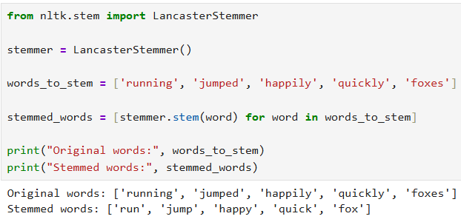
4. Regexp Stemmer
Regexp Stemmer is a flexible stemming algorithm that uses regular expressions (regex) to remove word suffixes based on custom rules.
- Allows custom stemming rules using regex
- Useful for domain-specific text processing
- Provides flexible and rule-based stemming
- Requires manual rule creation
- Can be slower for large datasets
Advantages
- Highly customizable using regular expressions.
- Suitable for domain-specific tasks.
Limitations
- Requires manual rule definition.
- Can be computationally expensive for large datasets.
Code and output:
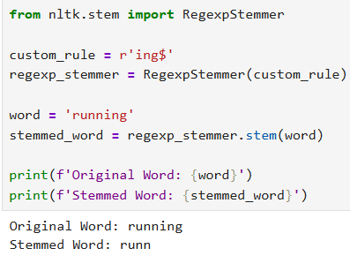
5. Krovetz Stemmer
Krovetz Stemmer is a linguistically aware stemming algorithm developed by Robert Krovetz. It focuses on preserving the actual meaning of words while converting them into their root forms.
- Preserves linguistic meaning more accurately
- Handles plural and tense conversions effectively
- Produces more meaningful root words
- Slower compared to many other stemmers
- May be less efficient for very large datasets
Advantages
- More accurate, as it preserves linguistic meaning.
- Works well with both singular/plural and past/present tense conversions.
Limitations
- May be inefficient with large corpora.
- Slower compared to other stemmers.
Note: The Krovetz Stemmer is not natively available in the NLTK library, unlike other stemmers such as Porter, Snowball or Lancaster.
Stemming vs. Lemmatization
Let's see the tabular difference between Stemming and Lemmatization for better understanding:
Feature | Stemming | Lemmatization
Output | Reduces words to their root form, which may not be a valid word | Reduces words to their base form (lemma), producing a meaningful word
Approach | Uses simple rule-based methods | Considers meaning and context of the word
Processing Speed | Faster and simpler process | More accurate but computationally heavier
Part of Speech (POS) | Does not consider part of speech | Uses part of speech and context
Context Awareness | No context is considered | Considers the context and part of speech
Output Validity | May generate non-dictionary words | Produces valid dictionary words
Example | Better → Bet | Better → Good

Lemmatization:
Lemmatization Techniques
There are different techniques to perform lemmatization each with its own advantages and use cases
1. Rule Based Lemmatization
In rule-based lemmatization, predefined rules are applied to a word to remove suffixes and get the root form. This approach works well for regular words but may not handle irregularities well.
For example:
Rule: For regular verbs ending in "-ed," remove the "-ed" suffix.
Example: "walked" -> "walk"
While this method is simple and interpretable, it doesn't account for irregular word forms like "better" which should be lemmatized to "good".
2. Dictionary-Based Lemmatization
It uses a predefined dictionary or lexicon such as WordNet to look up the base form of a word. This method is more accurate than rule-based lemmatization because it accounts for exceptions and irregular words.
For example:
- 'running' -> 'run'
- 'better' -> 'good'
- 'went' -> 'go
"I was running to become a better athlete and then I went home," -> "I was run to become a good athlete and then I go home."
By using dictionaries like WordNet this method can handle a range of words effectively, especially in languages with well-established dictionaries.
3. Machine Learning-Based Lemmatization
It uses algorithms trained on large datasets to automatically identify the base form of words. This approach is highly flexible and can handle irregular words and linguistic nuances better than the rule-based and dictionary-based methods.
For example:
A trained model may deduce that “went” corresponds to “go” even though the suffix removal rule doesn’t apply. Similarly, for 'happier' the model deduces 'happy' as the lemma.
Machine learning-based lemmatizers are more adaptive and can generalize across different word forms which makes them ideal for complex tasks involving diverse vocabularies.
Code and output:
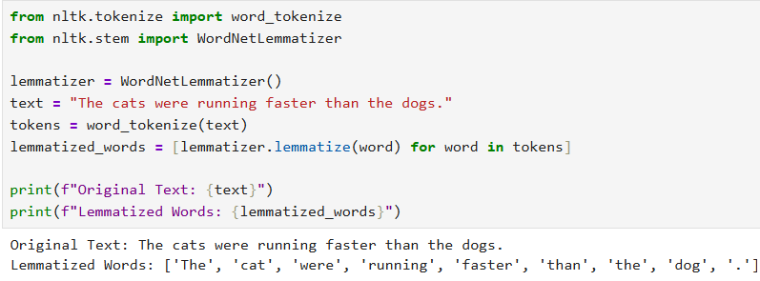
Improving Lemmatization with Part of Speech (POS) Tagging
Code and output:
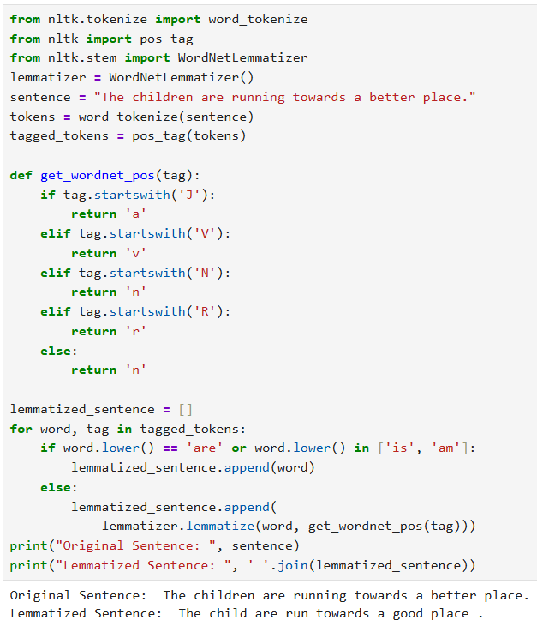
Advantages
- Reduces the number of unique words in datasets
- Improves memory and computational efficiency
- Enhances search and information retrieval accuracy
- Makes text data more consistent for NLP models
- Improves prediction accuracy and context understanding
Disadvantages
- Slower than stemming because of dictionary and grammar analysis
- Not ideal for real-time applications requiring fast processing
- Can produce ambiguous results for words with multiple meanings
- Requires more computational resources compared to simpler techniques
Text normalization:
- Input text string
Text normalization begins by taking the input text that will be processed in the following steps.
Code and output:
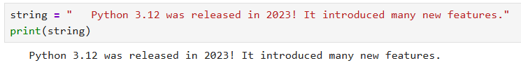
2. Case Conversion
- Converts uppercase letters to lowercase.
- Improves consistency in text data.
- Standardizes similar words.
Code and output:
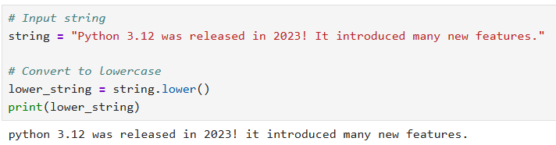
3. Removing Numbers
- Removes unnecessary numerical values.
- Simplifies text preprocessing.
- Commonly performed using Regular Expressions (Regex).
Code and output:
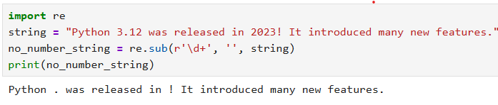
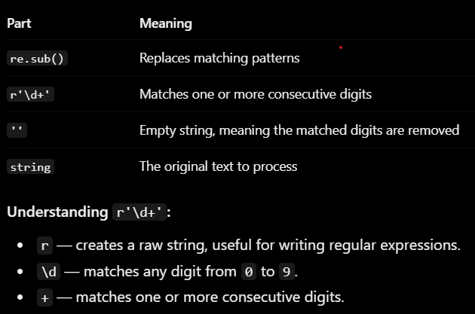
4. Removing punctuation
- Removes punctuation symbols from text.
- Simplifies text preprocessing.
- Commonly performed using Regular Expressions (Regex).
Code and output:
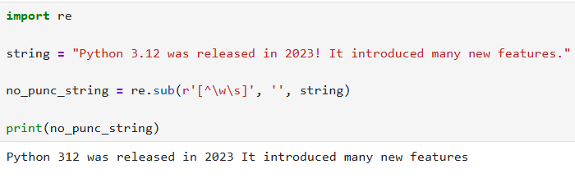
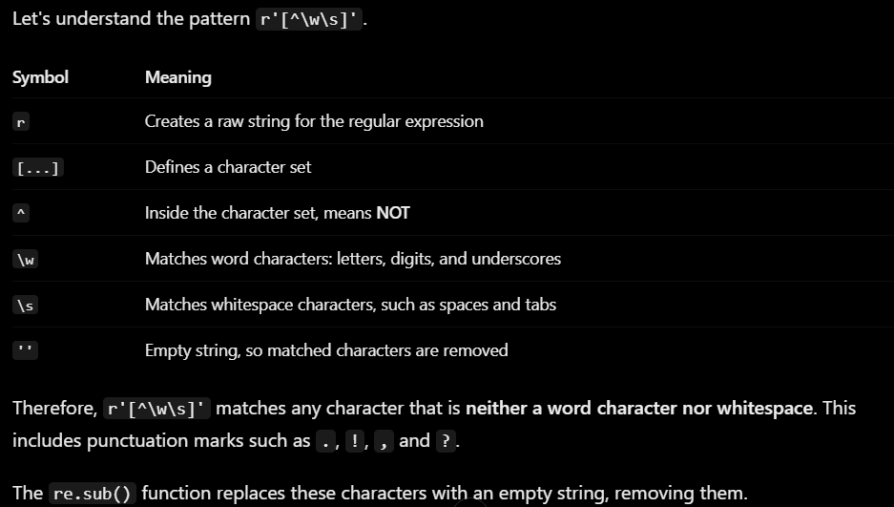
5. Removing White space
- Removes leading and trailing spaces.
- Helps standardize text.
- Improves preprocessing consistency.
Code and output:
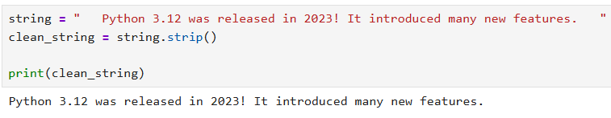
strip()
Removes whitespace from both ends
6. Removing Stop Words
- Removes commonly used words with little semantic value.
- Focuses on meaningful words in the text.
- Improves the efficiency of NLP tasks.
- Commonly performed using the NLTK library.
Code and output:
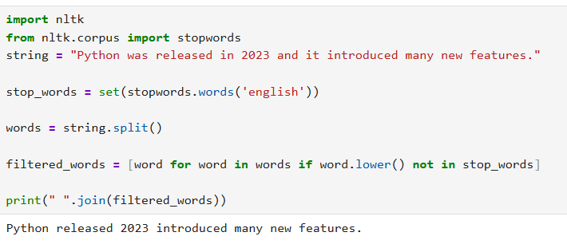Applications
- Sentiment Analysis: Normalizes text before sentiment prediction by removing inconsistencies such as case differences and unwanted characters.
- Text Classification: Standardizes documents so classifiers can extract consistent features from the input text.
- Search Engines: Cleans user queries and indexed documents to improve matching accuracy during retrieval.
- Chatbots and Virtual Assistants: Processes user input into a consistent format for better intent recognition.
- Text Mining: Removes textual noise to simplify keyword extraction and pattern discovery from large document collections.
- Machine Translation: Standardizes source text before translation to improve preprocessing quality.
Advantages
- Produces consistent and standardized text data.
- Removes unnecessary characters and formatting noise.
- Improves the accuracy of downstream NLP models.
- Reduces vocabulary size, making processing more efficient.
- Simplifies feature extraction for text analytics.
Limitations
- Removing numbers or punctuation may discard useful information.
- Stop word removal can affect sentence meaning in some tasks.
- Different NLP applications require different normalization strategies.
- Over-normalization may reduce important contextual information.
- Domain-specific text often requires custom preprocessing rules.
POS(Parts-Of-Speech) Tagging in NLP
Parts of Speech (PoS) tagging is a fundamental task in Natural Language Processing (NLP) where each word in a sentence is assigned a grammatical category such as noun, verb, adjective or adverb.
- This process help machines to understand the structure and meaning of sentences by identifying the roles of words and their relationships.
- Analyzes the context of words to determine their correct part of speech
- Improves text analysis, parsing, machine translation, and information extraction
- Widely used in text classification, sentiment analysis, chatbots, and search engine
Eg of POS tags used:
- "The" is tagged as determiner (DT)
- "quick" is tagged as adjective (JJ)
- "brown" is tagged as adjective (JJ)
- "fox" is tagged as noun (NN)
- "jumps" is tagged as verb (VBZ)
- "over" is tagged as preposition (IN)
- "the" is tagged as determiner (DT)
- "lazy" is tagged as adjective (JJ)
- "dog" is tagged as noun (NN)
Code and output:
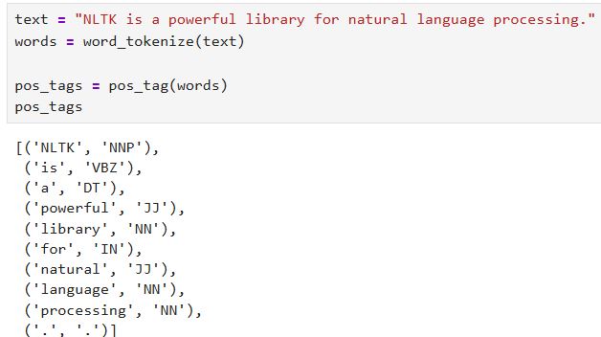
OR
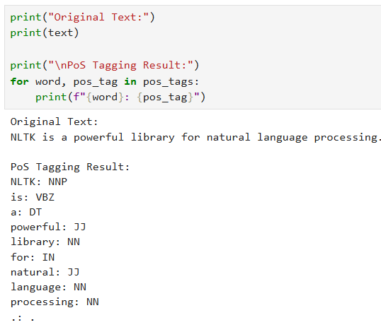
With SpaCy library:
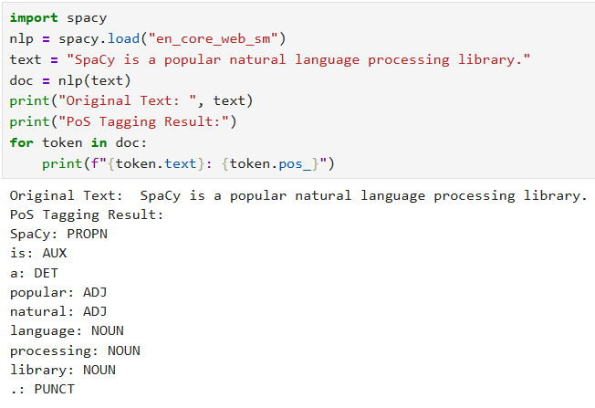
Challenges
- Ambiguity: Words can have multiple meanings depending on the context which can make tagging difficult.
- Idiomatic Expressions: Informal language and idioms may be hard to tag correctly.
- Out-of-Vocabulary Words: Words that haven’t been seen before can lead to incorrect tagging.
- Domain Dependence: Models may not work well outside the specific language domain they were trained on.

